Lab Assignment – 2
Name : G.Abhilash
HT.No : 2303A52195

Batch : 35

Task 1: Statistical Summary for Survey Data
Use Google Gemini in Colab to generate a Python function that reads a list of numbers and calculates the mean, minimum, and maximum values.
- Screenshot of Gemini prompt and result
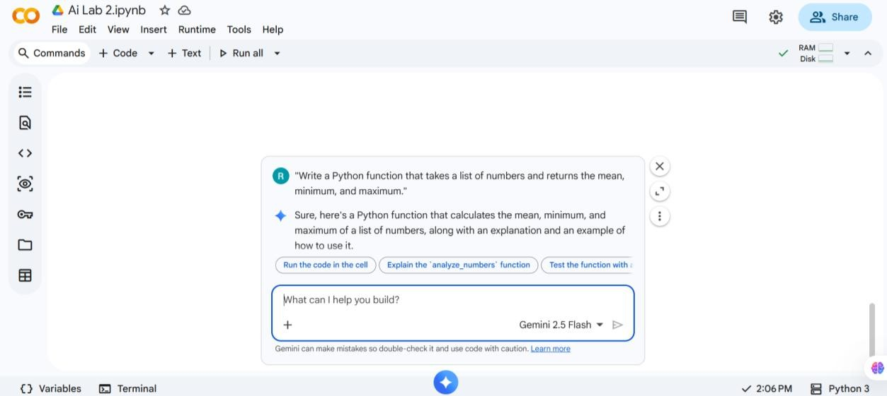
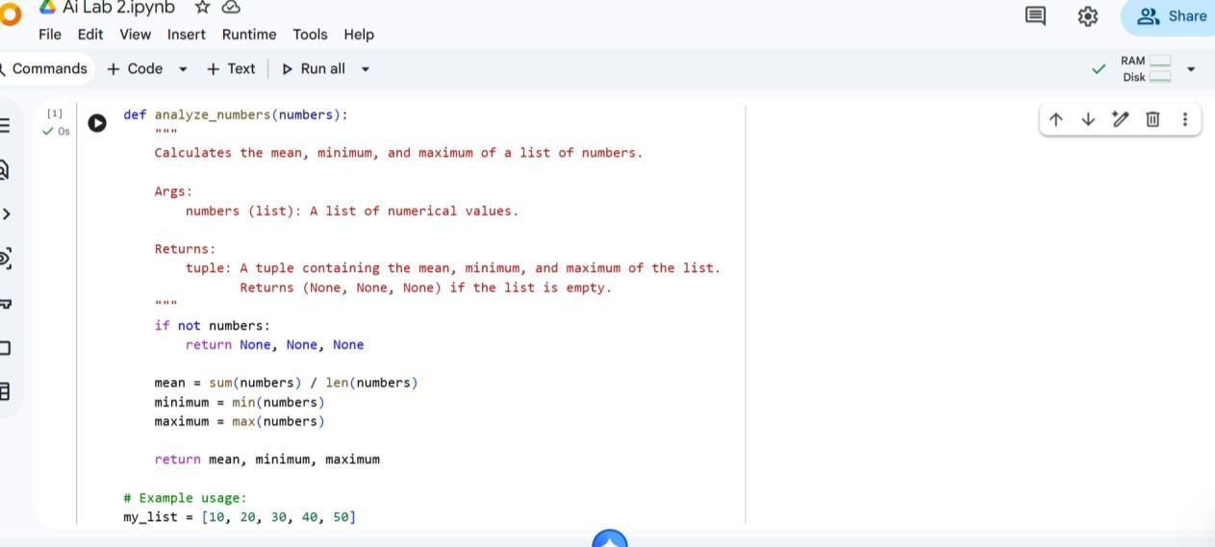

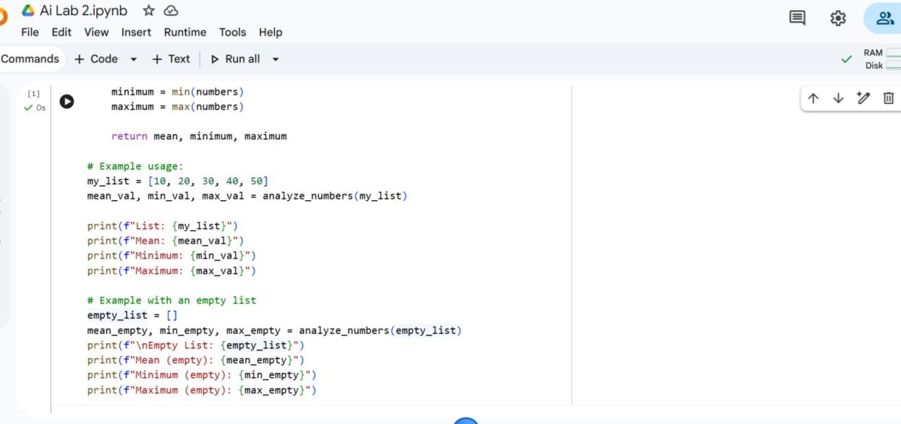
OUTPUT :
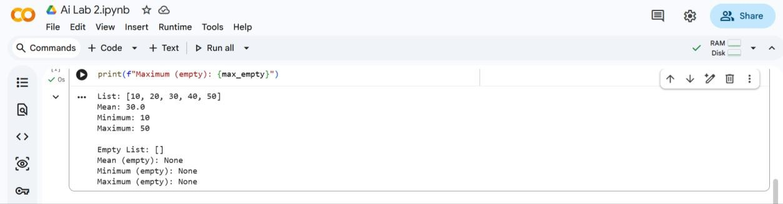

Explanation
  - def analyze_numbers(numbers):: This defines a function
named analyze_numbers that takes one argument, numbers, which is expected to be a list.
  - Docstring: The triple-quoted string explains what the function does, its arguments (Args), and what it returns (Returns). This is good practice for documenting your code.
  - if not numbers:: This line checks if the input list numbers is empty. If it is, the function returns (None, None, None) to avoid errors (like division by zero for the mean or min()/max() on an empty list).
  - mean = sum(numbers) / len(numbers): Calculates the mean (average) by summing all numbers in the list using sum() and dividing by the count of numbers using len().
  - minimum = min(numbers): Finds the smallest number in the list using the built- in min() function.
  - maximum = max(numbers): Finds the largest number in the list using the built- in max() function.

  - return mean, minimum, maximum: The function returns these three calculated values as a tuple.
Task 2: Armstrong Number – AI Comparison
Generate an Armstrong number checker using Gemini and GitHub Copilot.
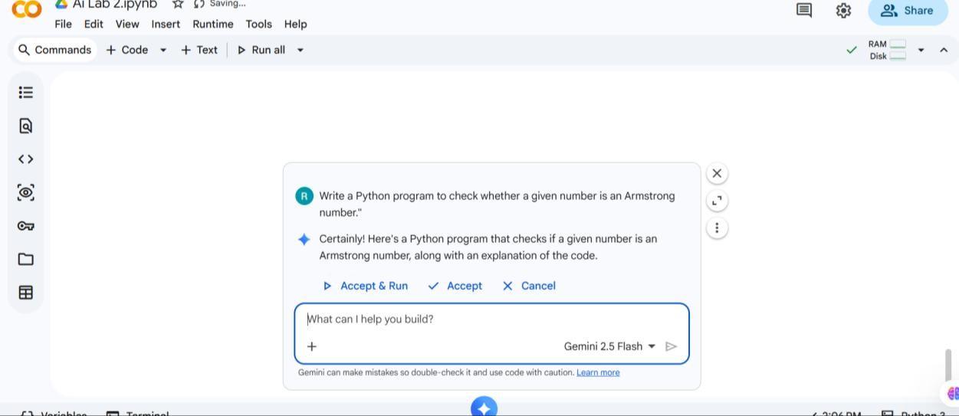
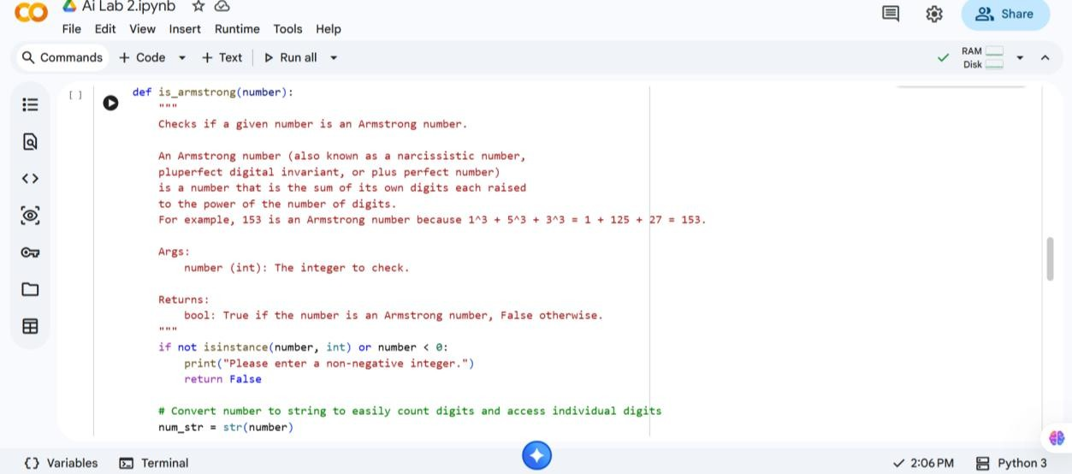
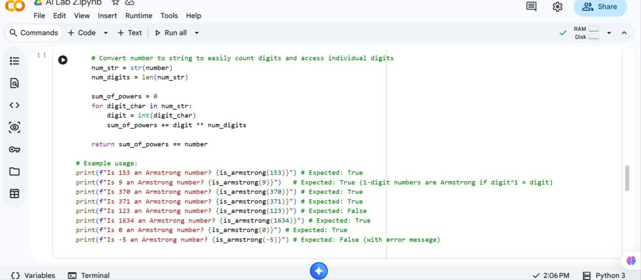

OUTPUT :
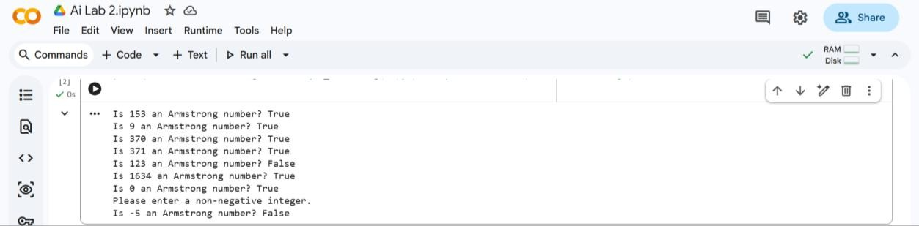
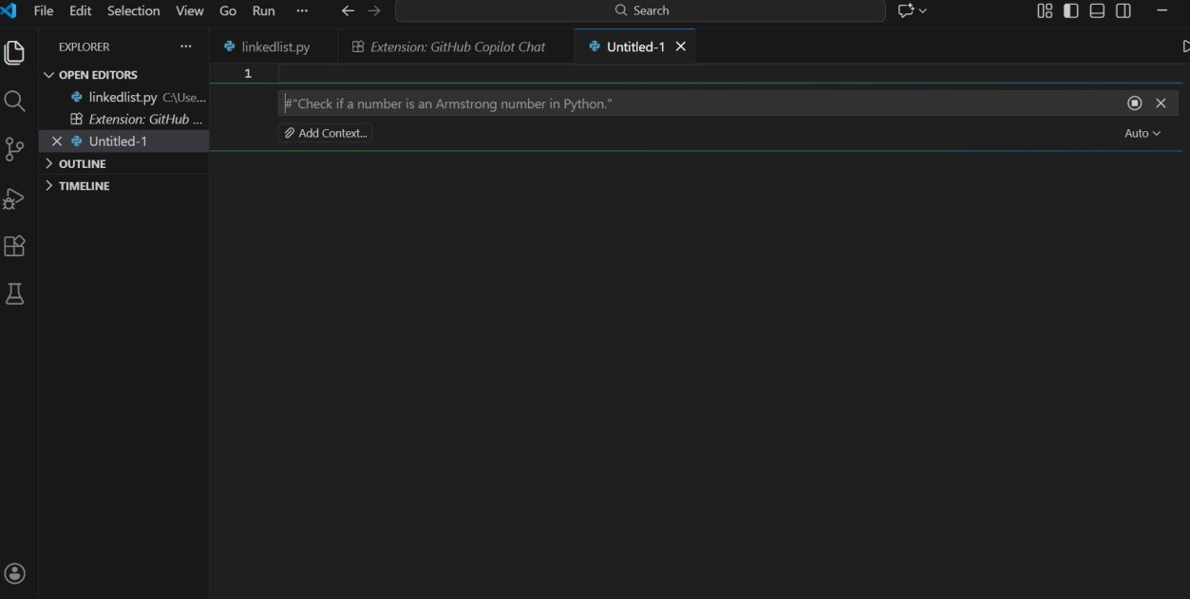
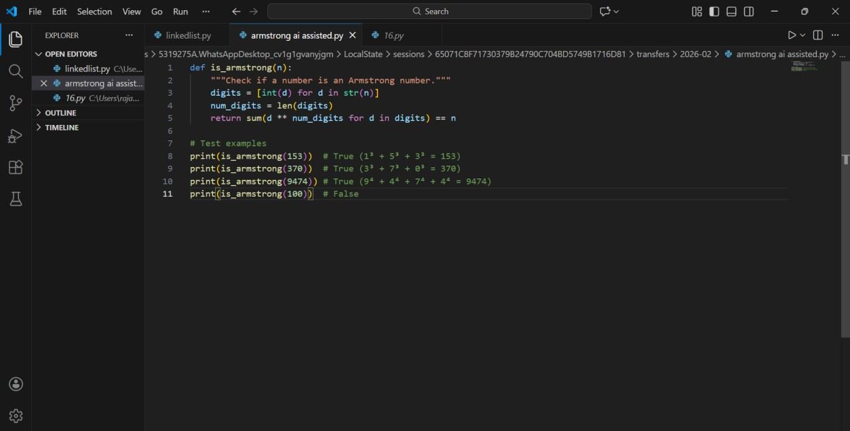

OUTPUT :

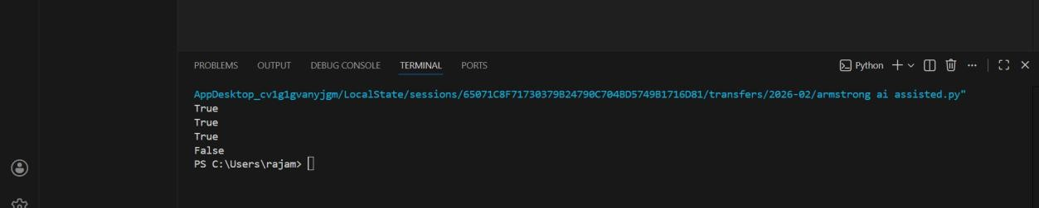
Explanation :
  - def is_armstrong(number):: This defines a function named is_armstrong that takes one argument, number, which is expected to be an integer.
  - Docstring: The triple-quoted string explains what the function does, its arguments (Args), and what it returns (Returns). It also clarifies the definition of an Armstrong number.
  - Input Validation: if not isinstance(number, int) or number < 0: checks if the input is a non-negative integer. Armstrong numbers are typically defined for non-negative
integers. If invalid, it prints a message and returns False.
  - Convert to String: num_str = str(number) converts the input number to a string. This makes it easy to:
    - num_digits = len(num_str): Get the number of digits.
    - Iterate through each digit.

Calculate Sum of Powers:
    - sum_of_powers = 0 initializes a variable to store the sum.
    - The for loop iterates through each character (digit_char) in the num_str.
    - digit = int(digit_char) converts the character back to an integer.
    - sum_of_powers += digit ** num_digits calculates the digit raised to the power of the total number of digits and adds it to the running sum.
  - Comparison: Finally, return sum_of_powers == number compares the calculated sum with the original number. If they are equal, the number is an Armstrong number, and the function returns True; otherwise, it returns False.

Comparison Table

Feature | Google Gemini | GitHub Copilot
Logic Style | Uses string conversion | Uses mathematical operations
Code Structure | Function-based | Inline procedural code

Feature | Google Gemini | GitHub Copilot
Readability | Very clear and beginner-friendly | Slightly complex but efficient
Lines of Code | More | Fewer
Ease of Understanding | High | Medium
Suitability for Beginners | Excellent | Good

Task 3: Leap Year Validation Using Cursor AI
Use Cursor AI to generate a Python program that checks whether a given year is a leap year.
Use at least two different prompts and observe changes in code. Prompt 1
Write a Python program to check whether a given year is a leap year
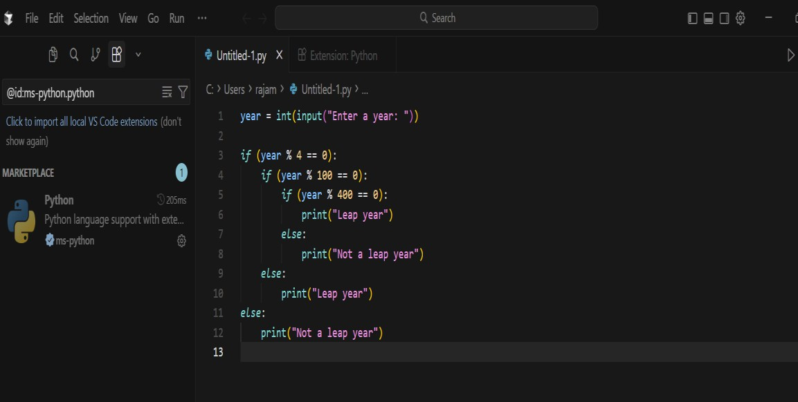

OUTPUT :
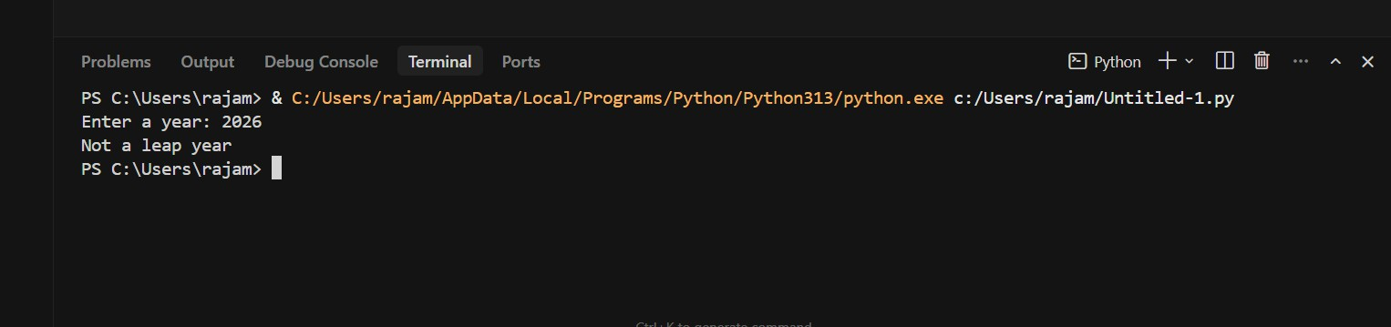

Prompt 2
Write an optimized and user-friendly Python program to validate leap year with proper comments

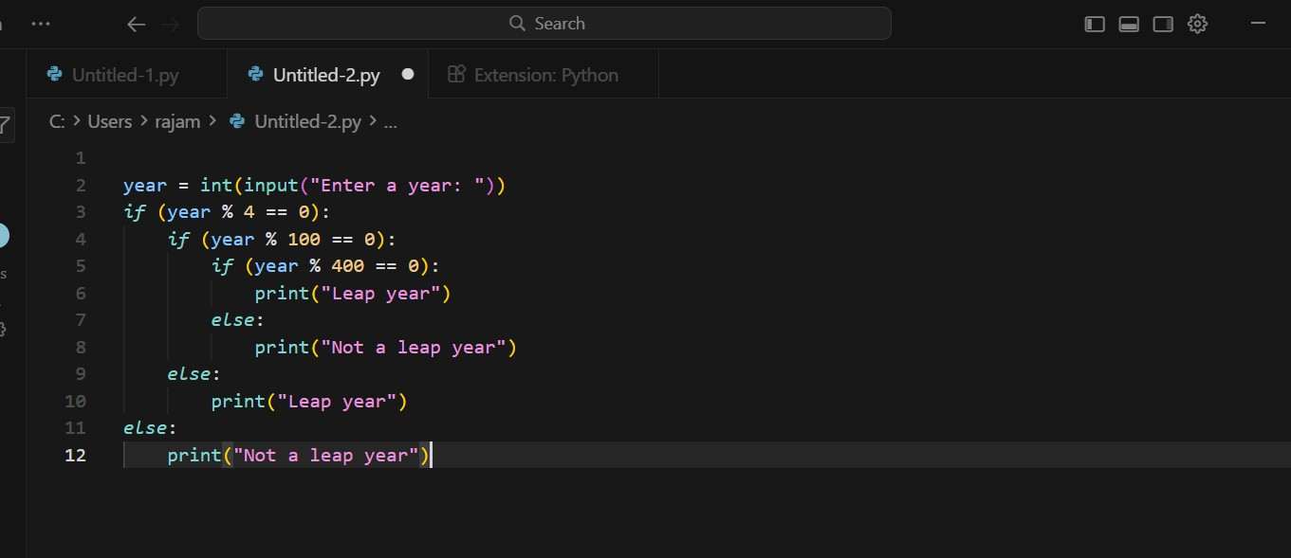
OUTPUT
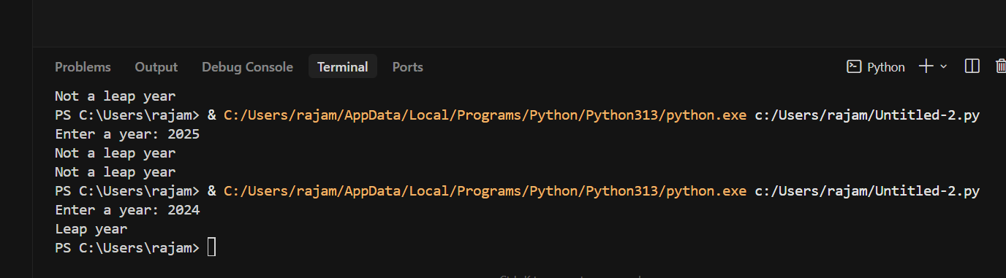

Comparison Between the Two Versions

Feature | Version 1 | Version 2
Prompt Type | Simple | Optimized
Code Structure | Procedural | Function-based

Feature | Version 1 | Version 2
Readability | Good | Very Good
Reusability | Low | High
Comments & Documentation | No | Yes
Suitable for Backend Systems | Medium | High

Conclusion:
Using different prompts in Cursor AI results in improved code quality, better structure, and higher maintainability.
Task 4: Student Logic + AI Refactoring (Odd/Even Sum)
Write a Python program that calculates the sum of odd and even numbers in a tuple, then refactor it using any AI tool.

Original code
t = (1, 2, 3, 4, 5, 6)
even_sum = 0
odd_sum = 0 for i in t:
if i % 2 == 0:
even_sum = even_sum + i else:
odd_sum = odd_sum + i
print("Sum of even numbers:", even_sum) print("Sum of odd numbers:", odd_sum) Output
Sum of even numbers: 12 Sum of odd numbers: 9

Refactored Code
t = (1, 2, 3, 4, 5, 6)
even_sum = sum(num for num in t if num % 2 == 0) odd_sum = sum(num for num in t if num % 2 != 0) print(f"Sum of even numbers: {even_sum}")
print(f"Sum of odd numbers: {odd_sum}")

Output
Sum of even numbers: 12 Sum of odd numbers: 9

Explanation of Improvements

Aspect | Original Code | Refactored Code
Code Length | More lines | Fewer lines
Logic Style | Traditional loop | Pythonic (list comprehension)
Readability | Good | Very clear and concise
Performance | Normal | Slightly optimized
Maintainability | Medium | High

